**Maria Schnebli, first Liaison Prosecutor for Switzerland, returns home**

27/06/2019

Maria Schnebli, who joined Eurojust in March 2015 as the first Liaison Prosecutor for Switzerland, will depart at the end of July. She will be rejoining the Attorney General’s Office in Berne, supervising all international corruption investigations, and leading some investigations herself.  
  
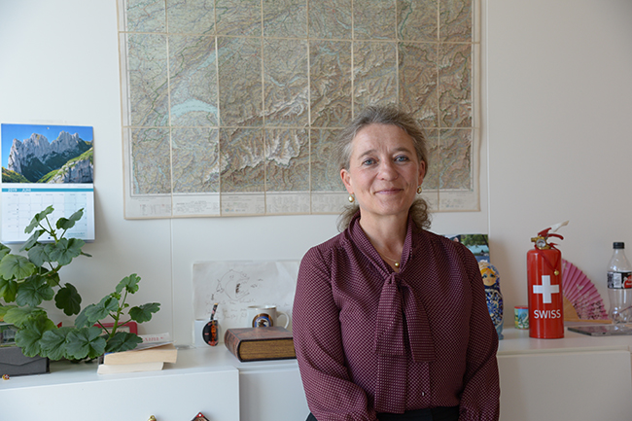Switzerland cooperates on the basis of the Council of Europe’s 1959 MLA Convention and especially the second additional protocol concerning participation in joint investigation teams (JITs). The legal basis for cooperation between Eurojust and Switzerland is the the [Cooperation Agreement](http://www.eurojust.europa.eu/doclibrary/Eurojust-framework/agreements/Agreement%20between%20Eurojust%20and%20Switzerland%20(2008)/Eurojust-Switzerland-2008-11-27-EN.pdf)which was signed in November 2008 and entered into force in 2011.  
  
During Ms Schnebli’s time at Eurojust, the Swiss Liaison Prosecutor has been involved in big cases, many with Europol, and many supported by JITs, which included the Cantonal Prosecution Offices for the first time. Aside from Eurojust, Switzerland has no other Liaison Prosecutors, but only police attachés.  
  
Switzerland has been a constant presence as well as an extremely active contributor to the work of Eurojust, and has organised and chaired [coordination meetings](http://www.eurojust.europa.eu/Practitioners/operational/Pages/coordination-meetings.aspx) at Eurojust as well as a[coordination centre](http://www.eurojust.europa.eu/Practitioners/operational/Pages/eurojust-coordination-center.aspx). The Swiss Liaison Prosecutor is the leader in caseload in comparison to other Liaison Prosecutors. In 2018, the Swiss Liaison Prosecutor:  
  
• initiated 88 new cases, and had 137 cases ongoing from previous years;  
• participated in 135 new cases initiated by other Desks, and was involved in 252 cases ongoing   from previous years; and  
• participated in 40 coordination meetings and 10 JITs  
  
Ms Schnebli’s association with Eurojust goes back to being the Swiss contact point to Pro-Eurojust since 2001 and then the operational contact point to Eurojust until 2015. She was uniquely qualified for her positions in international judicial cooperation, among other reasons, because she speaks seven languages fluently.  
  
Ms Schnebli graduated from the University of Zürich with a degree in law, and became a member of the Bar of the Canton of Zürich in 1998. She joined the Office of the Attorney General of Switzerland in 2001 as a Federal Prosecutor. She received her LL.M. from the University of Zürich and the Institute for European Studies in 2002. From September 2012 until her secondment to Eurojust, Ms Schnebli served as Head of the Competence Centre for International Mutual Legal Assistance in Criminal Matters at the Office of the Attorney General, personally responsible for executing incoming MLA requests and advising other departments, as well as advising the Attorney General on matters of international cooperation. She also conducted complex national criminal investigations involving money laundering, organised crime, corruption and terrorism.  
  
When asked about her time as a Liaison Prosecutor at Eurojust, Ms Schnebli said: ‘I do not think you can have a government position in your national administration with so much liberty. This liberty is, however, linked to an enormous responsibility to constantly serve both your home authorities and Eurojust. Home authorities also may not realise that when someone returns home, they bring with them enormous added value, the value that comes from the knowledge and trust built up with all the National Desks and authorities during the secondment. Being together in one building allows this trust to be created.’  
  
Ms Schnebli wishes to thank everyone at Eurojust for their great cooperation, hard work, and sense of humour. The current Deputy Liaison Prosecutor, Ms Tanja Bucher, will succeed her.